INSTRUCTIONS TO E-SIGN YOUR CONTRACT

- Go to the school website, www.acgcschools.org
- Click the AC Weblink or GC Weblink icon at the bottom of the page listed under Staff Resources
- Login Page- Your user ID is the first three letters of your last name and the first three letters of your first name…..all lowercase and no spaces. Password is the last four of your SS#.
- You will come to this screen:

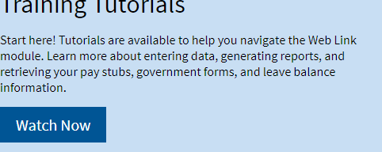
- Hover your mouse over Employee Information, move down to Personal Information, click on View/Add File Document
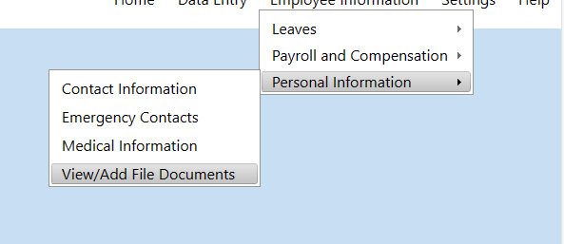
- Click on View Documents

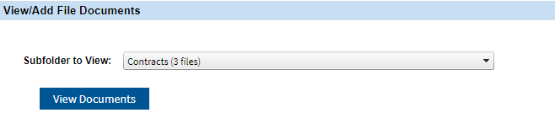
- Double click on the 2024-2025 Contract. Contract will be displayed.
- Click the E-Sign symbolat the top of the page. This will change symbols at the top left of the page to allow you to create your signature.

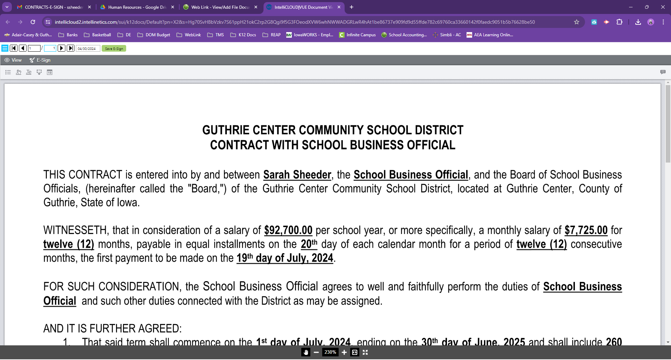
- 2. 3. 4.

- Click on symbol 1 to create a freehand signature using your mouse OR click symbol 2 to type in your name and choose the style of signature. The “Save for Later” box will be checked to save your signature for future use. Click Save
- Click symbol 3 to place the signature on the signature line. Your cursor will turn into a pencil. Click the screen and your signature will appear. Click the signature again and you will have blue dots around your signature. From there you can move the signature and resize to fit on the signature line. Click outside the signature to remove the blue dots once finished.
- Click Symbol 4 to place the date. Your cursor will turn into a pencil. Click the date line and the date will appear. Click the date again to resize and place on the date line.
- Click the green box “Save E-Sign”
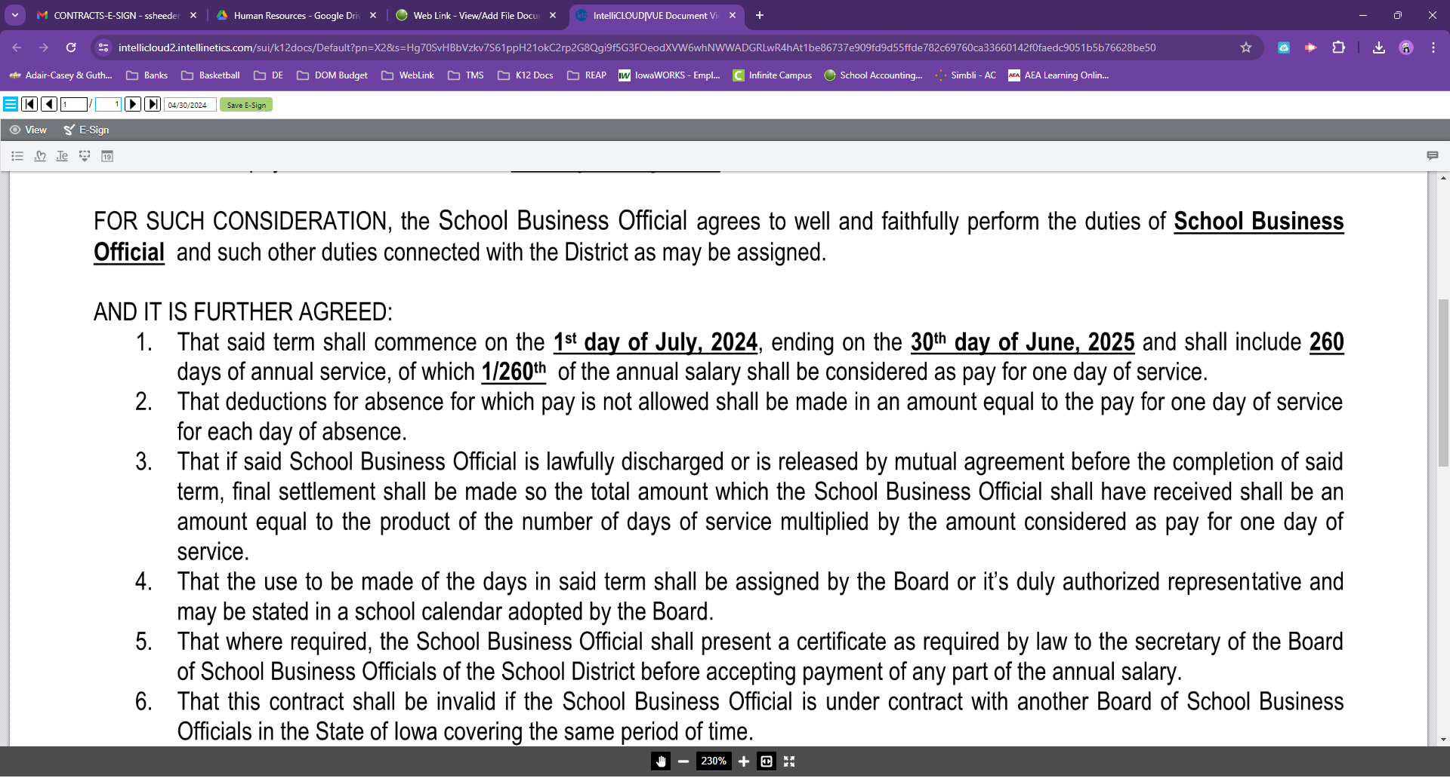
A message will appear stating the changes were saved; click OK.
- To Print a copy of your contract, select View in the upper left corner, then select the printer symbol on the upper right hand corner.

